# Learning about urban climate solutions

# Supplementary information

William F. Lamb1*, Felix Creutzig1,2, Max C. Callaghan1,3, Jan C. Minx1,3

1 Mercator Research Institute on Global Commons and Climate Change, Torgauer Straße 12-15, EUREF Campus #19, 10829 Berlin, Germany

2 Technische Universität Berlin, Straße des 17. Juni 135, 10623 Berlin, Germany

3 School of Earth and Environment, University of Leeds, Leeds LS2 9JT, UK

* [lamb@mcc-berlin.net](mailto:lamb@mcc-berlin.net)

## Additional Figures and Tables

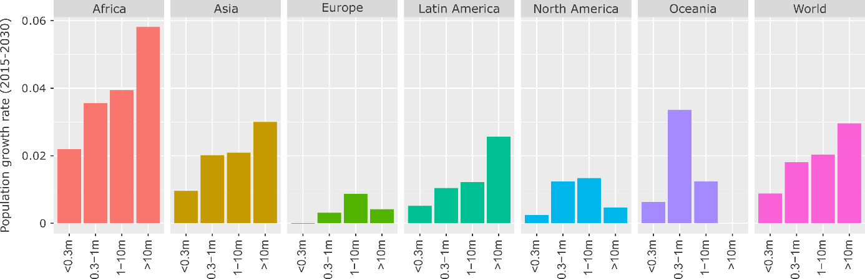

**Figure 1: Projected population growth rate by region and city size, 2015-2030.** Population data from ref 7, using agglomeration data where available.

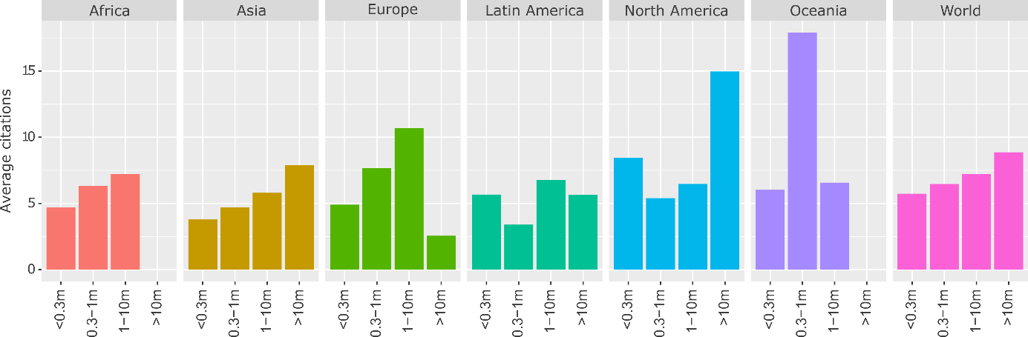

**Figure 2: Average citations of urban case studies by region and city size.** Citations are divided equally among cities in double-counted articles. Population data from ref 7, using agglomeration data where available.

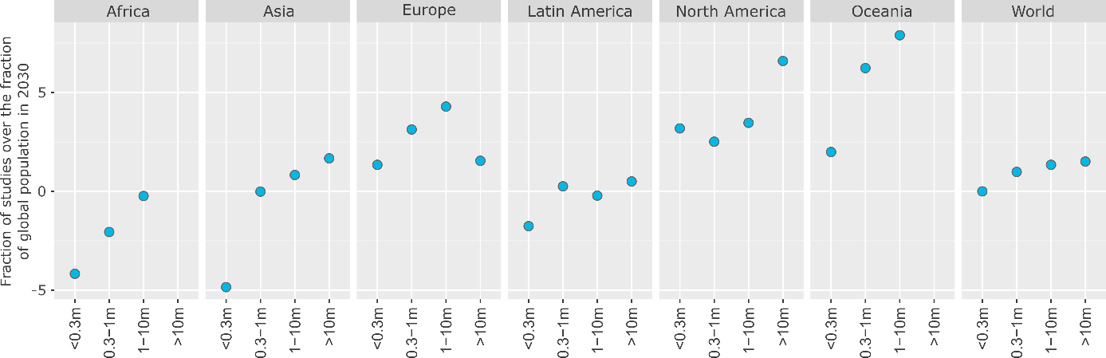

**Figure 3: The global distribution of urban case studies versus population**. To normalise, where the numerator (% of global population in a region & city size) exceeds the denominator (% of case studies in a region & city size), we subtract the fraction from 2. Population data from ref 7, using agglomeration data where available.

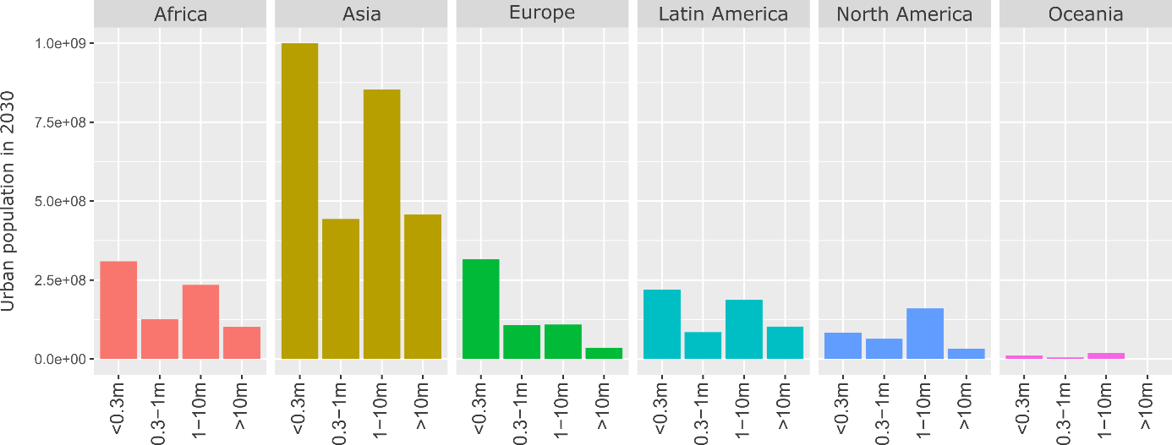

**Figure 4: Total urban population in 2030 by region and city size.** Population data from ref 7, using agglomeration data where available.

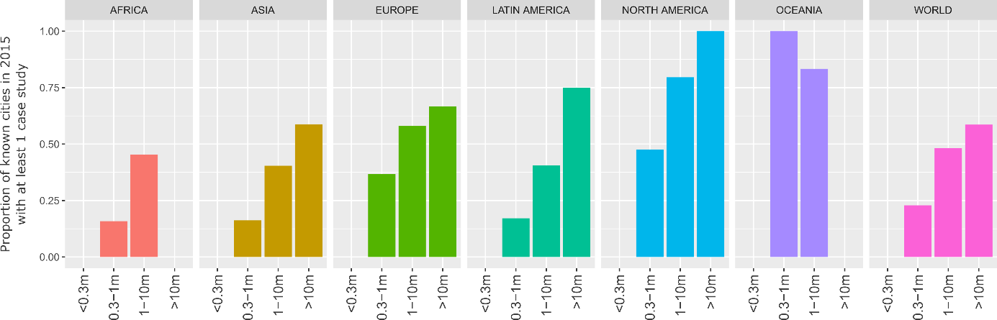

**Figure 5: Direct coverage of case studies.** Missing values for small cities are due to absent data; missing values for mega-cities (Africa, Oceania) indicate no documented mega-cities in these regions as of 2015. Population data from ref 7, using agglomeration data where available.

|  |  |  |  |
| --- | --- | --- | --- |
| **ID** | **Topic Name** | **Stemmed Keywords** | **Marginal Topic Distribution** |
| 1 | Urban governance | citi; polici; govern; local; develop | 9.3 |
| 2 | Energy consumption | energi; consumpt; effici; sector; beij | 7.9 |
| 3 | Urban form | urban; area; land; ecolog; model | 7.2 |
| 4 | Solar PV | system; solar; power; electr; energi | 7.0 |
| 5 | CO2 emissions | carbon; emiss; industri; china; lowcarbon | 6.8 |
| 6 | Buildings | build; design; energi; perform; residenti | 6.8 |
| 7 | Climate adaptation | climat; chang; adapt; risk; govern | 6.5 |
| 8 | Air pollution | air; pollut; health; qualiti; concentr | 6.2 |
| 9 | Transportation | transport; travel; traffic; public; car | 5.7 |
| 10 | GHG emissions | ghg; emiss; greenhous; gas; reduct | 5.4 |
| 11 | Vehicles | vehicl; electr; fuel; drive; emiss | 4.8 |
| 12 | Households | household; incom; electr; survey; hous | 4.7 |
| 13 | Waste management | wast; landfil; solid; manag; msw | 4.6 |
| 14 | Water demand | water; suppli; manag; demand; treatment | 4.6 |
| 15 | Heat demand | heat; district; thermal; demand; network | 4.6 |
| 16 | Green roofs | roof; temperatur; cool; green; surfac | 4.5 |
| 17 | Urban ecology | tree; forest; plant; speci; sequestr | 3.4 |

**Table 1: List of topics and their keywords.** Topic names are manually coded by the authors based on a review of the stemmed keywords and associated documents. The marginal topic distribution denotes the percentage of the document set where this topic is found.

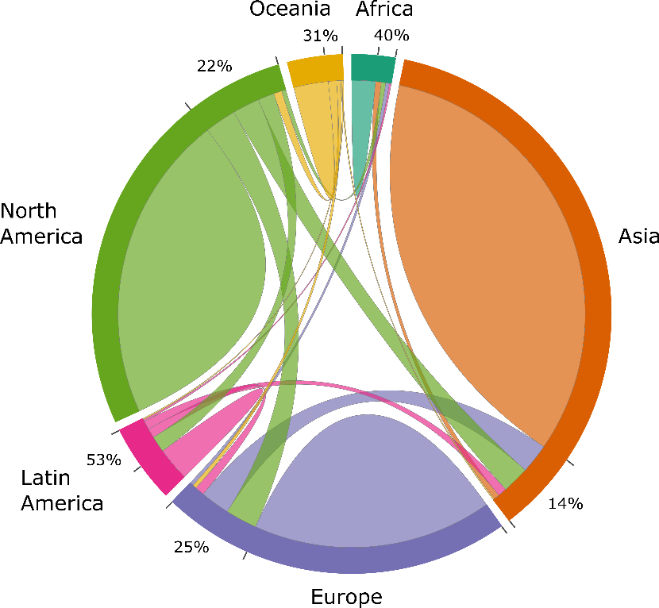

**Figure 6: Inter and intra-regional comparative research on urban climate mitigation.** Each link in the chord diagram is based on the pairwise coupling of two cities within a document. Documents where more than one city is mentioned in the abstract are used, totalling 699 studies. The proportion of regional couplings that pair with other regions (i.e. inter-regional urban comparisons) are indicated as percentages.

|  |  |  |  |
| --- | --- | --- | --- |
| **Authors** | **Year** | **Title** | **Topics** |
| Khalil, H.A.E.E. | 2009 | Energy efficiency strategies in urban planning of cites | Urban governance; Energy consumption; Urban form |
| Attia, S & De Herde, A | 2010 | Active solar retrofit of a residential house, A case study in Egypt | Buildings; Heat demand; Green roofs; Solar PV |
| Fahmy, M & Sharples, S | 2011 | Urban form, thermal comfort and building CO2 emissions - a numerical analysis in Cairo | Buildings; GHG emissions; Green roofs; Urban form |
| El-Deeb, K, El-Zafarany, A & Sherif, A | 2012 | Effect of building form and urban pattern : On energy consumption of residential buildings in different desert climates | Buildings; Urban form |
| Verdeil, E, Arik, E, Bolzon, H & Markoum, J | 2015 | Governing the transition to natural gas in Mediterranean Metropolis: The case of Cairo, Istanbul and Sfax (Tunisia) | Urban governance; Energy consumption; Heat demand; Urban form |
| Dabaieh, M, Wanas, O, Hegazy, MA & Johansson, E | 2015 | Reducing cooling demands in a hot dry climate: A simulation study for non-insulated passive cool roof thermal performance in residential buildings | Buildings; Green roofs |
| Kares, M & Singh, P | 2016 | Assessment of building integrated photovoltaics for the residential section in representative Urban areas in Egypt | Buildings; Energy consumption; Households; Solar PV; Urban form |
| Aboulnaga, M. | 2016 | High-rise buildings in context of sustainability; urban metaphors of greater Cairo, Egypt: A case study on sustainability and strategic environmental assessment | Buildings |

**Table 2: Urban climate mitigation literature on Cairo**

|  |  |  |  |
| --- | --- | --- | --- |
| **Topic** | **Proportion** | **Topic** | **Proportion** |
| GHG emissions | 0.19 | Urban form | 0.08 |
| Transportation | 0.16 | Water demand | 0.08 |
| Air pollution | 0.16 | Waste management | 0.07 |
| CO2 emissions | 0.14 | Solar PV | 0.07 |
| Energy consumption | 0.12 | Households | 0.06 |
| Urban governance | 0.11 | Heat demand | 0.06 |
| Vehicles | 0.10 | Urban ecology | 0.05 |
| Climate adaptation | 0.10 | Green roofs | 0.04 |
| Buildings | 0.10 |  |  |

**Table 3: Topic proportions of 'forward-looking' case studies**

|  |  |  |  |
| --- | --- | --- | --- |
| **Region** | **No. case studies** | **No. ‘forward-looking’ studies** | **Fraction** |
| Africa | 175 | 4 | 0.02 |
| Asia | 1761 | 190 | 0.10 |
| Europe | 1207 | 129 | 0.11 |
| Latin America | 246 | 26 | 0.11 |
| North America | 1126 | 84 | 0.07 |
| Oceania | 184 | 19 | 0.10 |

**Table 4: Regional coverage of 'forward-looking' case studies**

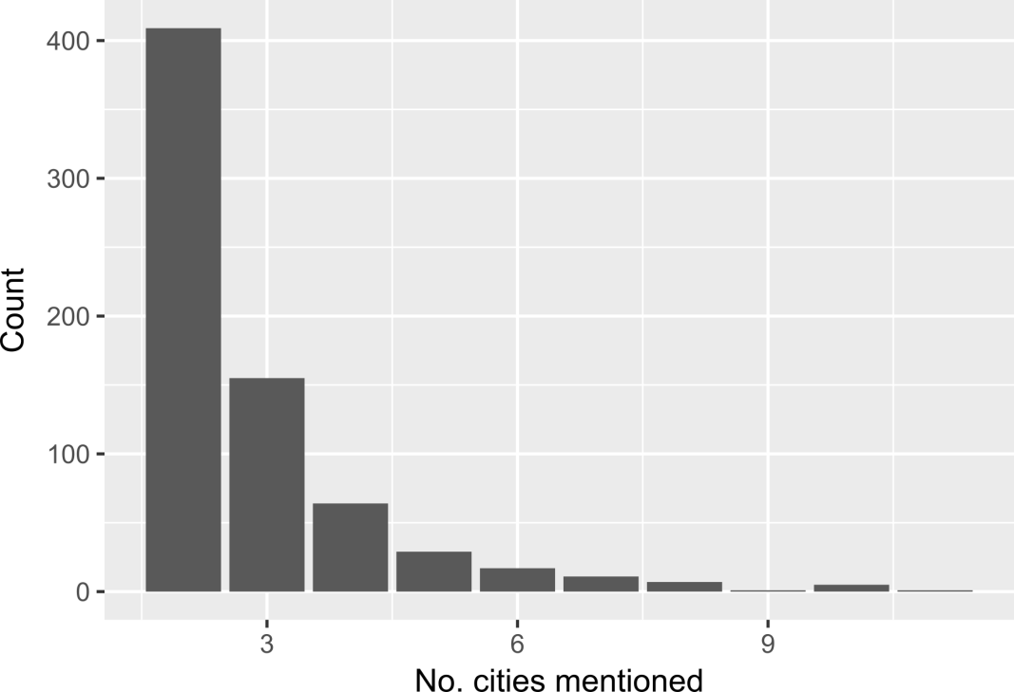

**Figure 7: Number of cities mentioned in comparative studies**